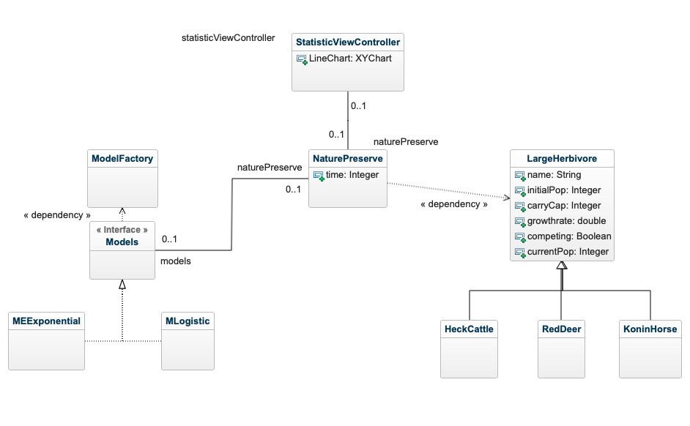

Supply

Demand

Transition

Controller